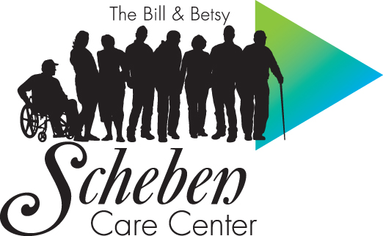

Caregiver Tip Sheet

“10 Ways to Tell Your Loved One” about Adult Day Services
1
Fun, fellowship, and getting out in the community!! Highlight the social aspects and downplay the care aspects of the center. The center can be described as a social club.
2
Discuss the productive aspects of the activities at the center. Explain that she/he may be there to attend a meeting or to volunteer to help others.
3
Describe some of the activities that might be of interest to her/him, and explain that this is an opportunity to rediscover old interests as well as discover new interests.
4

Encourage her/him to just try it for a week or so.
5

Ask her/him to do it for you, because you love her/him. She/he will be safe, and you can go to work and not worry.
6
Ask her/him to do it for the whole family. It gives everyone a break from each other, and helps the family get along better.

Talk over the health aspects that will enhance her/his physical wellness. Explain that the nurse can monitor blood pressure, check blood sugar, administer medication, or do special “therapy,” such as range of motion to improve strength.
7
8
Explain that the doctor has suggested the use of the center, and ask the doctor to write an order or prescription for the program.
9
Explain that this is something that she/he must do. Do not give her/him a choice. If necessary, go with her/him so she/he will not feel alone or abandoned.
10
Don’t!! If your loved one is highly anxious, do not discuss the visit in advance. The orientation and explanation can take place at the center.

Community Services of Northern Kentucky – dba The Bill & Betsy Scheben Care Center
Serving your community since 1923 – Providing Medical Day Program, Respite and Transportation

31 Spiral Drive  Florence, KY 41042  Voice/TDD (859) 525-1128  Fax (859) 525-0351

